**Coursework cover sheet – be sure to keep a copy of all work submitted**

**Coventry University**

Section A – To be completed by the student – PLEASE PRINT CLEARLY IN SINGLE PAGE

|  |  |  |  |  |
| --- | --- | --- | --- | --- |
|  | | | Module Code:  **351EM Project Management**  (Submission date & SCOPE stamp)  27th November, 2021 | |
| Student Names (Surname first, in alphabetically order) and ID numbers:   |  |  | | --- | --- | | **Name** | **Student ID** | | **Chan Yik Kit Amy** | **56237852** | | **Lai Justine** | **56235545** | | **Tsang Yung Rosita** | **56273550** | |  |  | |  |  | | | |
| Programme Title & Programme Code  **BSc (Hon) in Information Technology Business** | | |
| Time taken (in hrs)  40 hrs. | | |
| Lecturer  **SB Teng** | | Tutor  **SB Teng** | | |
| Module Code and Title  **351EM Project Management** | | Due Date:  1.Presentation, Week 10 tutorial,  40% of module mark  2. Final Report, Turnitin before week 12.  60% of module mark | | |
|  | | Extension & late submissions allowed:  **No** | | |
| Estimated time (in hrs)  **40 hrs./student** | Assignment Type: | % of Module Mark  **100%** | | Hand-out date:  **09 Sept 2021** |
| Late Submission Policy: Coursework submitted after the due date will not be accepted and a zero mark will be awarded. Please refer to Student Handbook for full details on Late Submission Policy. | | | | |
| Declaration: ~~I~~ / We the undersigned confirm that ~~I~~ / We have read and agree to abide by the University regulations on plagiarism and cheating and Late Submission Policy. ~~I~~ / We confirm that this piece of work is ~~my~~ / our own. ~~I /~~ We consent to appropriate storage of our work for checking to ensure that there is no plagiarism / academic cheating.  Signatures:  Chan Yik Kit Lai Justine Tsang Yung | | | | |

Section B – To be completed by the assessor

|  |  |  |  |
| --- | --- | --- | --- |
| Intended learning outcomes assessed by this coursework:   1. Define the business case, aim and objectives of a project, while examining the project management environment within an organization. 2. Understand the behavioural excellence and professionalism levels needed for creating, managing and motivating project teams successfully. 3. Identify the effects of projects on individuals and stakeholders and be able to develop an effective project team within an organization. 4. Select, apply and evaluate project management concepts, tools, techniques and methodology for the effective and successful implementation of a project in any realm/domain. 5. Discuss the need for good project procurement methods, contract strategies, and their operational principles. | | | |
| Marks breakdown | | Max | Awarded |
| Part 1: Group Presentation (40%)  Overall Presentation  Individual Presentation  Responses to Questions  Part 2: Group Project Report (60%) | | 20  10  10    60 |  |
| Assessor’s signature / initials: | Date: | Total  100 | Total |
| Extension Agreed until:  Programme Leader Signature: | Penalty Due:  (Yes/No) | Penalty | Final Mark |
| Signed internal moderator: |  | | |
| This section may be used for feedback or other information | | | |

**Project Management - HK Tech 300**

**Title: IOT system of vending machine in Hong Kong**

* 1. **Business case**

|  |  |  |  |
| --- | --- | --- | --- |
| **Project Business Case** | | | |
| **Project Name** | IoT (Internet of Things) System of Vending Machine in Hong Kong Market | | |
| **Project Sponsor** | HK Tech 300 (with other sponsors) | **Project Manager** | Amy Chan |
| **Date of Project Approval** | 1st December 2021 | **Last Revision Date** | 1st November 2021 |
| **Contribution to Business Strategy** | Our strategy is to project best supports in industry vending machine services, and the current situation does not reflect this. The new IoT (Internet of Things) system will ensure all products of vending machines are refilled in a timely manner. It will also ensure that machines are worked with efficiently and stable. These two facts align this project to the company strategy. | | |
| **Options Considered** | **Options considered included:** | | |
| 1. Creating database to manage machine status and data instead of human | | |
| 2. Having notices of refill situation and status report of products generated automatically | | |
| 3. Developing an application for vending machines in Hong Kong (divided by companies) | | |
| **Benefits** | 1. Increased sales - currently estimated we lose 15% of all sales transactions due to current issues. | | |
| 2. Happier customers - we estimate better customer satisfaction and more convenient buying experience will increase at least by 30% through application development. | | |
| 3. Improved machine efficacy and performance - longer the lifetime of machines to reduce depreciation by 5% due to the better repairment which to enhance the net profit | | |
| 4. Boarded market - we estimate more product types and shops joined by improved customer buying experience will increase 10% or above profits and commissions. | | |
| **Timescales** | Initial analysis shows that the system will take approximately 6 months to implement and approximately a month for project preparation. | | |
| **Costs** | IoT System and application development = $380,000 | | |
| Project Management = $200,000 | | |
| Develop team = $500,000 | | |
| Consultant of machine and companies of product apply = $120,000 | | |
| Testing machines = $380,000 | | |
| Computers = $120,000 | | |
| Rent of office and administrative costs = $300,000 | | |
| **Total estimated cost = $2,000,000** | | |
| **Expected Sales on Investment** | 1st Year = $0 | | |
| 2nd Year = $1,200,000 as IoT system and Database begins to be felt and application implemented. | | |
| 3rd Year = $1,800,000 as IoT system and application begins to be felt. | | |
| **Risks** | Right now, the project looks pretty straightforward but there are some unknow surrounding implementations. There is also the risk that the application and changes do not meet the product supplier or customers’ needs. For this reason, it is recommended to involve the development team closely. | | |

* 1. **Project Budget Plan**

**6 months project (HKD)**

1. Assume 20 man-days per month
2. One full time PM = $2000 per man-day
3. One full time Junior PM = $1000 per man-day
4. 4 full time programmers at $1500 per man-day
5. Consultation Fee (duration 60 man-days in total) at $1000 per man-day
6. Training & support (duration 50 man-days) at $800 per man-day
7. 4 Testing Machines each at $95000
8. 12 Laptops each at $10000
9. 2 printers each at $10000
10. One part time (50%) accountant = $500 per man-day
11. Reserve = 20% of total budget estimate
12. Rent and administrative costs = $2500 per man-day
13. 2 servers each at $20000

|  |  |  |  |
| --- | --- | --- | --- |
| **WBS Activities** | **Duration (man-days)** | **Cost per man-day** | **Total** |
| 1. Project Management |  |  |  |
| 1.1 Full Time Project Manager | 120 | 2,000 | 240,000 |
| 1.2 Full Time Junior Project manager | 120 | 1,000 | 120,000 |
| 1.3 Part Time accountant | 60 | 500 | 30,000 |
| 2. Consultation fee | 60 | 1,000 | 60,000 |
| 3. Programming | 120 | 2,000 | 240,000 |
| 4. Testing Machine | 30 | 500 | 15,000 |
| 5. Training and Support | 50 | 800 | 40,000 |
| 6. Rent and administrative expenses | 120 | 2,500 | 300,000 |
| **a) Subtotal** | 680 | 10,300 | **1,045,000** |
|  | | | | |
|  | **Units** | **Cost per unit** | **Total** |
| 7. Hardware |  |  |  |
| 7.1 Laptops | 12 | 10,000 | 120,000 |
| 7.2 Servers | 2 | 20,000 | 40,000 |
| 7.3 Printers | 2 | 10,000 | 20,000 |
| 8. Testing Machines | 4 | 95,000 | 380,000 |
|  |  |  |  |
| **b) Subtotal** | 20 | 135,000 | **560,000** |
|  | | | | |
| **c) Total (a + b)** | 700 | 145,300 | **1,605,000** |
|  | | | | |
| **d) Reserve (20%)** | **321,000** |  |  |
|  | | | | |
| **TOTALS (c + d)** | **1,926,000** |  |  |

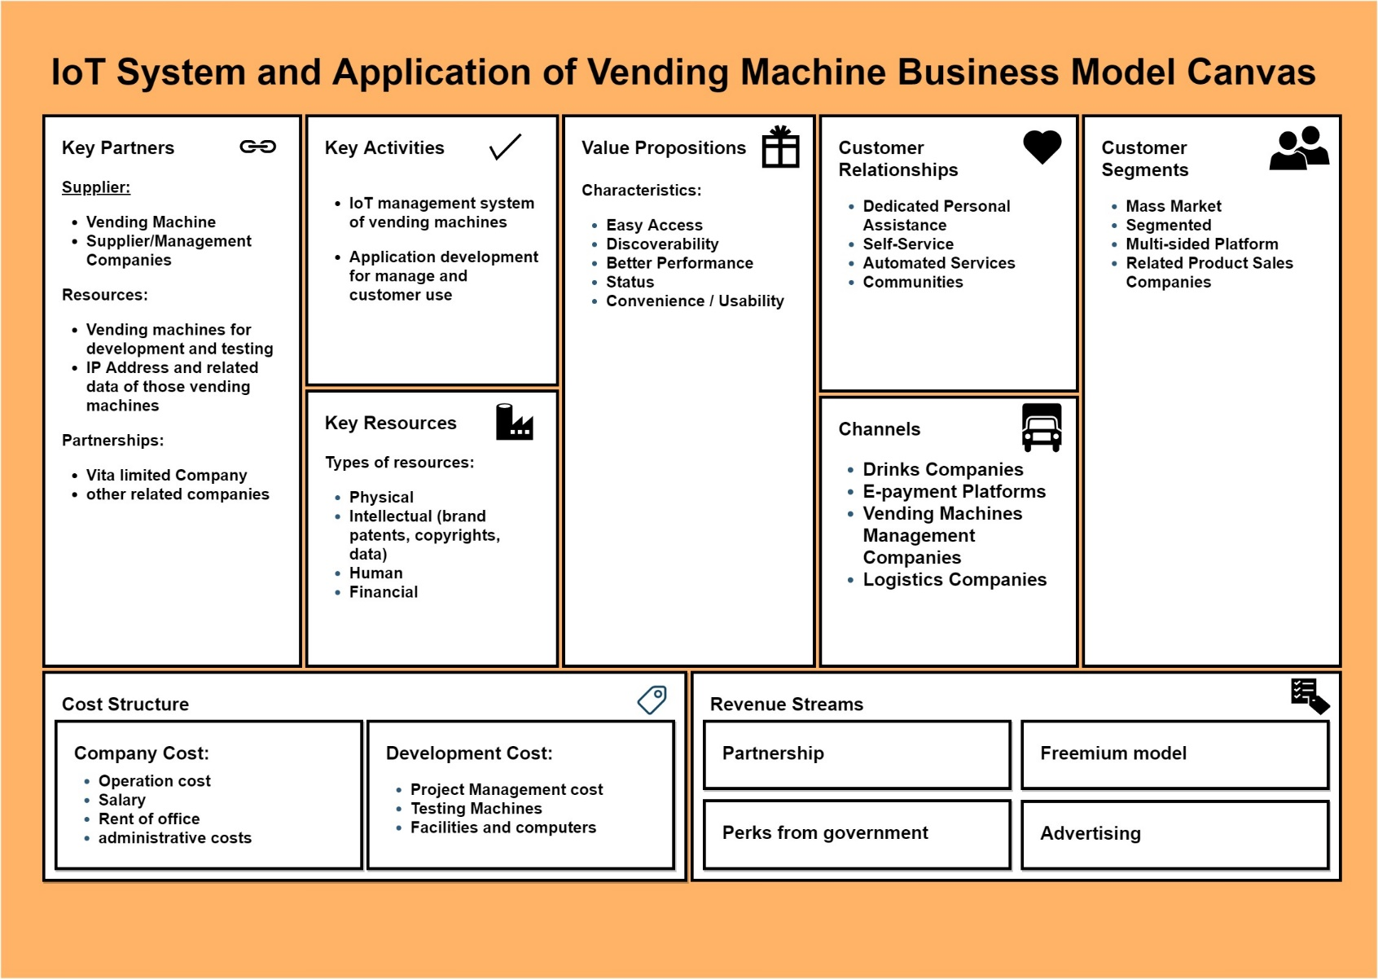**1.3) Business Model Canvas**

Through the above “IoT (Internet of Things) and application of Vending Machine Business Model Canvas” is providing the brief information and the structure of the business project plan; The testing machines and compulsory primary data (e.g. IP Address of vending machines) is needed for project which vending machines manufacturer and related management supplier have to provide. Apart from the key partners of them, Vita limited company and other later investors are key financial support of the project as well.

Basically, the project will mainly focus on two activities: IoT management system of vending machines, application development for manage support and customer use. Reasonable distribution of resources in physical, intellectual management, human and financial will lead us to the goal which is to build the integrated management platform and enhance user experience of vending machines in Hong Kong. Easier access, widen discoverability, more smooth performance and convenience.

In addition, customer relationships are an indispensable part for this project. The final product and service aims to dedicate personal assistance, personalize self-service, automatic service progress and contribution to communities. The project got 4 main customer segments: related product sales companies and segmented potential users in internal, multi-sided platforms and the mass market in external. The market consists chiefly of companies of drinks, e-payment platforms, vending machines management and logistics services for their backstage support of vending machines management and border market sales.

Lastly, the financial structure of this project is slightly described by cost and revenue company costs in the above canvas. Costs distributed in parts of the company and development which generally includes operations, salaries and administrative; project management, machines testing and needed facilities. Revenues are predominantly coming from partnerships, freemium model, perks from government and advertising. By backstage support IoT systems, partners could be more flexible in decision making and data collection through agile methods replace ineffective excel-and-human calculations with frequent data collection while the technology data and implements enhance the community technology development which is expected by the government.

**2) Stakeholders Register**

|  |  |  |  |  |  |
| --- | --- | --- | --- | --- | --- |
| **ID** | **Role** | **Power (H/M/L)** | **Interest (H/M/L)** | **Needs & wants** | **Concerns** |
| 1 | Sponsor (Vita) | H | H | Project finance sponsor and wants the project completed in 6 months | Complexity of interface to 3rd party vendor |
| 2 | Programmer | L | H | Time costing in development and implement | Development database, IoT connection system and the related application |
| 3 | Consultant | M | H | Discussion and report duties between sponsors, develop team and vending machine related companies | Join the project for first month and in implement period |
| 4 | Project Manger | H | H | Lead the develop team and distribute work, discuss to consultant | Lead the develop team and distribute work, discuss to consultant |
| 5 | Product Manager | M | H | Ability to quote quicker; competitive pricing | Evaluate and daily check the product quality |
| 6 | Functional Manager | M | M | Develop for month and processing | Evaluate and ensure the functions are work |
| 7 | UI Designer | L | H | UI analysis with developer | User interface design of the application for customer and partner companies |
| 8 | UX Designer | L | H | UX analysis with developer | User experience design to evaluate the applications |
| 9 | Accountant | L | M | Weekly and monthly report | Project costs manage in budget |
| 10 | Business Analyst | M | M | Weekly and monthly report | Analysis the market the vending machines |

The above stakeholder register describes the main 10 roles affected by a project, and their needs and wants, and concerns of the project to ensure proper engagement of stakeholders. The main sponsor of the project – Vita, got high power and high interest as it provides financial support for the 6 months project, the complexity of interface to third party vendors have to be concerned.

Secondly, senior leadership like project managers have the high power and interest to lead the development team and distribute work, sometimes they need to discuss with consultants based on different situations and for report progress.

Thirdly, Consultant, product manager, functional manager and business analyst are affecting the project direction and details developments indirectly but powerfully, for instance, discuss and report duties between sponsors, develop team and vending machine related companies, make sure the product quote a suitable price and qualities in a proper scope, therefore they got the middle power and nearly high or middle interest in the project.

Last but not least, programmer, user interface and experience designers and accountant are basically work on coding and financial management support, they will not join whole duration of the projects man-days, most of them need to lead by project manager and instructed by their supervisor so they got low power but high interest in the project.

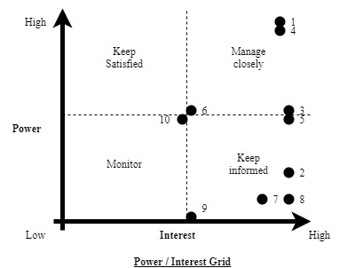

The above “Power and Interest Grid” shows for reference the graphical views of the power and interest distribution of stakeholders related to the project. Mostly, the above almost half in 10 main roles have high interest but low power which it needs to keep informed during the project. At the same time, the others need to be managed closely during development of the project as they have high interest and power.

**3) Weighted Score Model**

|  |  |  |  |  |  |
| --- | --- | --- | --- | --- | --- |
| **Criteria** | **Weight** | **Mainland China** | **Hong Kong** | **India** | **Macau** |
| 1. Support key business objectives | 20% | 60 | 80 | 30 | 40 |
| 1. Has strong related sponsor | 10% | 70 | 60 | 25 | 30 |
| 1. Uses realistic level of technology | 15% | 60 | 65 | 20 | 30 |
| 1. Can be implemented in one year or less | 5% | 50 | 80 | 30 | 20 |
| 1. Ease of control on geographical size impacts | 10% | 45 | 65 | 10 | 30 |
| 1. Political stability | 15% | 45 | 80 | 20 | 40 |
| 1. Consumption abilities | 25% | 55 | 95 | 20 | 35 |
| **Weighted Project Scores** | **100%** | **55.5** | **78** | **22** | **34.25** |
| *1 - 100 (Worst - Best) |  |  |  |  |  |

The following is the criteria description of the weighted score model:

i.      Support key business objectives

It is defined as an integrated evaluation of the ability of a market environment that maintains profitability and productivity, has excellent customer service and employee environment, has sustainable growth and maintaining positive cash flows, can deal with market changes and stay ahead of the market competition. It is very essential to the business of vending machines operation which means it has heaviest weighting in the score model. Both mainland China and Hong Kong have a mature and stable business environment which its performance above average while India and Macau are not good enough, more, Hong Kong gets a faster turnover and deals with the market changes, therefore Hong Kong has a better performance than mainland China, India and Macau in supporting key business objectives.

ii.     Has strong related sponsor

The character of the sponsor is directly affecting the profit and operation of the vending machine business which is better to have more joiners which makes it have a heavier weighting in the above score model. More potential investor and wider market would be more suitable for the business, Mainland China have the greater potential market of drinks companies and partners while India and Macau have a limited partnerships in this market, Hong Kong actually got more international market but mainland also got more stronger product manufacturer for product refills and sales, it resulted that mainland China have the strongest related sponsor compared with the other three countries.

iii.    Uses realistic level of technology

The more customers used to use technology related devices, the more profit would gain in this vending machine market as it is projected to produce the application for personalization and more convenient customer experience. There are low numbers of Indians and Macau residents who use mobile phones for e-payments similar to Alipay. At the same time, mainland China and Hong Kong citizens are used to using e-wallet platforms for online payment daily. Because the vending machines mostly have payment methods of coin and Octopus card already, Hong Kong citizens should be more convenient than mainland China citizens to use the vending machines by online payment as it provides a limited payment method in the present stage.

iv.    Can be implemented in one year or less

Consider of the distance away from the development and maintenance team, Hong Kong and mainland China should be closer than India and Macau, especially in the covid-19 situation, the quarantine costs time and money and which might affect the performance and profit gain of the vending machines in faraway country as there might not have skilful employee to fix the system and machines immediately in a short time. Compared to these four countries, Hong Kong locales should be the best implemented in a limited time with flexible and timely support.

v.     Ease of control on geographical size impacts

Similar to the above points but focus on the scope of controlling, India and Macau are too far away to control the system if there are any happen but mainland China and Hong Kong are geographically closer which make an easier control and flexible checking of system and machines. Basically, Hong Kong has a smaller size of landscape coverable so it has an easier geographical control if the implementation is held in Hong Kong as the teams are in Hong Kong.

vi.    Political stability

The stability of policy of a country will affect the business performance directly so it should have a higher weighting in the score model. India always has small scale wars and sometimes terrorist attacks so it has the worst policy performance compared with mainland China, Hong Kong and Macau. Macau still has huge numbers of citizens who are living under a poor situation, the scale is higher than Hong Kong and mainland China. Mainland China always defends with different and never-ending controversy and gradually worries of policy stability, similar to Hong Kong, but the scale of instability of policy is smaller than mainland China as it is regional, not as international as mainland China. Therefore, it resulted in Hong Kong having the most stable policy environment to do business.

vii.   Consumption abilities

The higher consumption abilities would have more opportunities to make more profits for the vending machines business so it should have higher weighting in the above score model. Obviously, Hong Kong and mainland China have greater shopping times and paying amounts than India and Macau. In addition, it is believed that Hong Kong has higher salary incomes and consumption amounts than mainland China averagely. Moreover, Hong Kong citizens are mostly willing to consume normally and the daily cost of living in Hong Kong is believably higher than the other three countries already. Apart from extra consumption transactions, the daily living costs are quite a great amount of the total consumption. Therefore, Hong Kong should be the best place to enable the vending machine business as it seems could gain the greatest number of profits in a period of time.

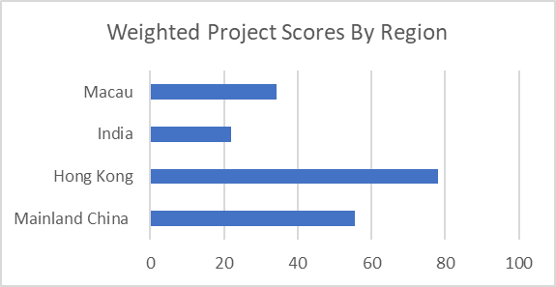

The bar chart of the “Weighted Project Scores by Region” shows that India only got 22 marks out of 100, Macau got 34.25 marks out of 100, mainland China had the second highest scores of more than half in 100 in total and Hong Kong got 78 marks out of 100 marks. India has the lowest score in the above weighted criteria while Hong Kong has the highest scores which resulted that Hong Kong having the best business situation and most potential conditions for this project and business productions.

**4) Project Charter**

|  |  |  |  |
| --- | --- | --- | --- |
| **Project Title：** IoT(Internet of Things) System of Vending Machine in Hong Kong Market  **Date of Authorization：** 1st December 2021  **Project Start Date：** 1st January 2022 **Target End Date：**30th June 2022 | | | |
| **Key Schedule Milestone：**   * Complete the IoT management system of vending machines by 1st April * Complete the application for management support and customer use by 30th June | | | |
| **Budget Information：**This project would be sponsored by HK Tech 300 and Vita for 2M, and more funds are available if needed. The majority of the costs of this project will be internal labour. All hardware will be brand new. | | | |
| **Project Manager：**Amy Chan, yikkchan8-c@my.cityu.edu.hk | | | |
| **Project Objectives:** IoT(Internet of Things) System of Vending Machine in Hong Kong Market project is a crucial project in the Vending Machine industry. This is the first charter for the project, and the objective is to complete the software for the IoT management system of vending machines in three months, and application development for management support and customer use in three months. | | | |
| **Main Project Success Criteria：**The software must meet all written specifications, be thoroughly tested, and be completed on time without over budget. | | | |
| **Approach：**   * Hire a part-time assistant for Amy Chan as soon as possible. * Within one month, develop a clear work breakdown structure, scope statement, and Gantt chart detailing the work required to complete the IoT system and the application. * Purchase all required hardware within one month. * Hold weekly progress review meetings with the core project team and the sponsor. * Conduct software testing per the approved test plans. | | | |
| **Projects Risks：**   * The purposes and needs are not clear enough.   + Risk of runaway costs or never-ending projects. * The project schedule is not clear.   + The project members may miss tasks and have the risk of progress delay * Lack of communication   + Risk of uncertainty, confusion, and misunderstanding * Unilaterally shortening the tasks.   + Error risk may increase * Natural disaster   + Risk of losing resources, materials, premises | | | |
| **Response Plan：**   * Double-check or rewrite the business case to clear the purpose and send it to the project board. * Conduct weekly meetings to share the plan and review tasks. * Hold planning workshops for members to understand the upcoming process. * Ensure to keep all the records of meetings and communications. * Use the most appropriate communications channel. * Sharing the schedule and explaining the risks of the changes with key stakeholders. * Familiarize the project team with emergency measures. * Make sure of the insurance. | | | |
| **Roles and Responsibilities** | | | |
| Name | Role | Position | Contact information |
| HK Tech 300 | Sponsor | Sponsor | - |
| Vita | Sponsor | Sponsor | - |
| Amy Chan | Project Manager | Manager | yikkchan8-c@my.cityu.edu.hk |
| Justine Lai | Team Member | Manager | justilai2-c@my.cityu.edu.hk |
| Rosita Tsang | Team Member | Manager | yungtsang5-c@my.cityu.edu.hk |
| Sign-off: (Signatures of all the above stakeholders)  **Amy Chan** **Justine Lai** **Rosita Tsang** | | | |
| Comments: (Handwritten or typed comment from above stakeholders, if applicable)  **It is decided to have more partners and investors of the vending machine provider and products suppliers in the foreseeable future if the project is performed positively.** | | | |

**5.1) Work Breakdown Structure (WBS)**

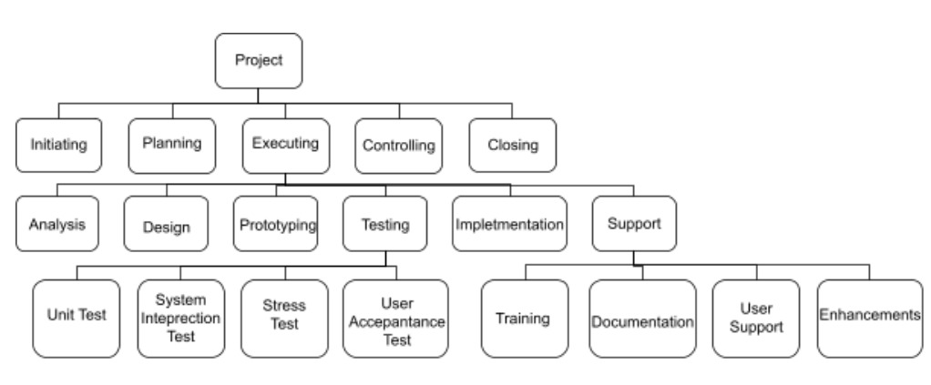

|  |  |
| --- | --- |
| Title | Description |
| **Stage One** | |
| Initiating | * Define project issues and requirements * Conceive and evaluate solutions to problems * Create project scope specification * Establish a project management team * Identify the stakeholders of the project * Hold a project kick-off meeting |
| Planning | * Define the content of the project plan * Planning project plan * Execute project plan * Review project plan |
| Executing | * Project management execution * Assign work subcontracting * Check all stages of the output process * Review the completion results of each stage * Project give out execution work |
| Controlling | * Scope control * Time control * Budget control * Resource control * Project team control * Quality control * Performance control * Risk control * Communication control * Documentation control |
| Closing | * Planning and closing matters * Communicate and assign case closing work * Carry out closing work * Make a case report * Hold a closing meeting |
| **Stage Two (In executing stage)** | |
| Analysis | * Process Analysis * Budgetary Analysis * Personnel Analysis * Risk Analysis * Client Requirements Analysis |
| Design | * Goals * Strategy * Details of the application * Vision * Problem may encounter * Recognize the necessary resources * Contingency Plan * Evaluation Plan * Budget |
| Prototyping | * Creating prototypes of the software * Getting early feedback |
| Testing | * Perform different kinds of testing |
| Implementation | * See the plans become a reality |
| Support | * Anything from advice and assistance to administrative services |
| **Stage Three (In testing stage)** | |
| Unit testing | * To validate that each unit of the software performs as expected |
| System Interaction Test | * To evaluate the system’s compliance with its specified requirement |
| Stress Testing | * To determine the robustness of software |
| User Acceptance Test | * Performed by the end-user or the client * To verify the software system before moving the software to the production environment |
| **Stage Three (In support stage)** | |
| Training | * Perform necessary training * Set up of a training environment * Delivery of training, or train-the-trainers training |
| Documentation | * User Manual * Test Document * Technical Document * Functional Document |
| User Support | * Reactive application support * Proactive application support |
| Enhancements | * Provide modifications or improvements to the Software * Improve performance or capacity of the Software * Provide additional functions to the Software |

**Responsibility Assignment Matrix (RAM)**

|  |  |  |  |  |  |  |  |  |
| --- | --- | --- | --- | --- | --- | --- | --- | --- |
|  | 1.1.1 | 1.1.2 | 1.1.3 | 1.1.4 | 1.1.5 | 1.1.6 | 1.1.7 | 1.1.8 |
| **Systems Engineering** | R | R P |  |  |  |  | R |  |
| **Software Development** |  |  | R P |  |  |  |  |  |
| **Hardware Development** |  |  |  | R P |  |  |  |  |
| **Test Engineering** | P |  |  |  |  |  |  |  |
| **Quality Assurance** |  |  |  |  | R P |  |  |  |
| **Configuration Management** |  |  |  |  |  | R P |  |  |
| **Integrated Logistics Support** |  |  |  |  |  |  | P |  |
| **Train** |  |  |  |  |  |  |  | R P |

* R = Responsible organizational unit P = Performing organizational unit

**Resource Histogram**

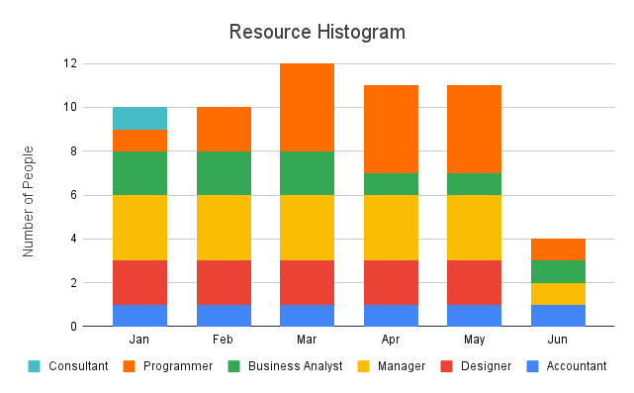

The above resource histogram shows our human resources treatment from 1st January to 30th June.

For the very first month, we need a consultant to help us to discuss and report duties between sponsors. Then we need project manager, product manager and functional manager help with the management. Also, we need a UI designer and a UX designer to design the draft with the programmer. It's in the planning stage so we just need 1 experienced programmer to draft the program. In addition, we need 2 business analysts to analyse the vending machines and write a weekly report. And 1 accountant to do the budget control weekly report.

In the mid period of the project, we need more programmers in order to share the workload so we have 4 programmers in total.

In the back half of the period, the needs of analysing the market will lessen since we already clear the system flow, so we just need 1 business analyst.

In the last month, most of the work should be done and just need some slight changes and advancements, so the resource needed will decrease.

**5.2)User Requirement Traceability Matrix (RTM)**

|  |  |  |  |  |  |
| --- | --- | --- | --- | --- | --- |
| **REQUIREMENTS TRACEABILITY MATRIX** | | | | | |
| **Project Name: IOT System of Vending Machine in Hong Kong** | | | | | |
| **Business Requirements Document (BRD)** | | **Functional Requirements Document (FSD)** | |  | **Test Case Document** |
| **Business Requirement ID#** | **Business Requirement / Business Use case** | **Functional Requirement ID#** | **Functional Requirement / Use case** | **Priority** | **Test Case ID#** |
| BR_1 | Vending Machine Modules | FR_1 | Type of machines location |  | TC#001  TC#002 |
|  |  | FR_2 | Allow input/edit/date |  | TC#003  TC#004  TC#005 |
|  |  | FR_3 | Status | High | TC#006 |
|  |  | FR_4 | Delete Records | Medium | TC#007  TC#008 |
| BR_2 | Payment Modules | FR_5 | By Octopus card | High | TC#009 |
|  |  |  | By Cash | High | TC#010 |
|  |  |  | By Digital wallet | High | TC#011 |
| BR_3 | Stock Calculating / Availability (Refill) | FR_6 |  |  | TC#012 |
| BR_4 | Partner / Membership modules | FR_7 |  |  | TC#013  TC#014 |
| BR_5 | Customer modules | FR_8 | Profile |  | TC#015 |
|  |  | FR_9 | Used History |  | TC#016 |
|  |  | FR_10 | Registration |  | TC#017  TC#018 |
| BR_6 | Staff Modules | FR_11 | Allowance, stronger staff | High | TC#019  TC#020 |
| BR_7 | Product Modules |  |  |  | TC#021  TC#022 |
| BR_8 | Function Modules |  |  | High | TC#023  TC#024 |
| BR_9 | Customer Feedback: |  |  |  | TC#025 |

**6) Gantt Chart**

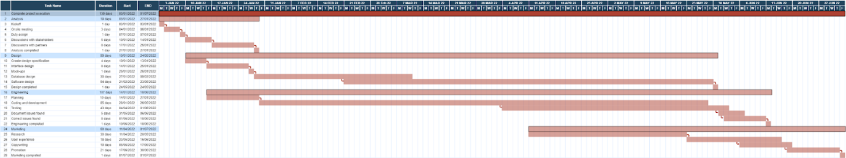  
The reference link here for clearer version:

<https://drive.google.com/file/d/126dpjedSHjC9moaatnl8Mz-Y6k4CqWfw/view?usp=sharing>

Gantt chart is used to show the schedule information by listing out project activities and their start and finish date in the calendar. It shows clear pictures of the project process, and lets us have better time management and better resource allocation on our work.

From the above Gantt chart, we can see that the estimated duration of the first part of the project is 130 days from January to June.

There are several parts in the Gantt chart, analysis, design, engineering, and marketing. For the analysis part, there are kickoff, onsite meetings, duty assignment, discussions with stakeholders and partners which will last for 19 days. For the design part, there are create design specifications, interface design, mock-ups, database design, and software design which will last for 99 days in total. For the engineering part, there are planning, coding and development. Testing. Document issues found, and correct issues found which will last the longest, 107 days. Lastly, for the marketing part, there is research, user experience, copywriting, and promotion for the project that will last for 60 days.

**7) Network Diagram**

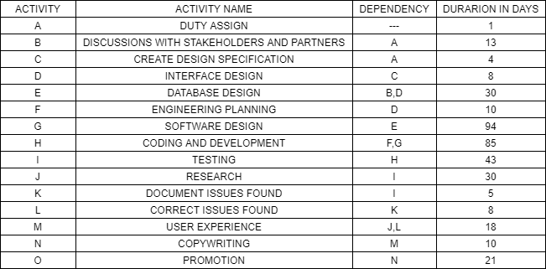

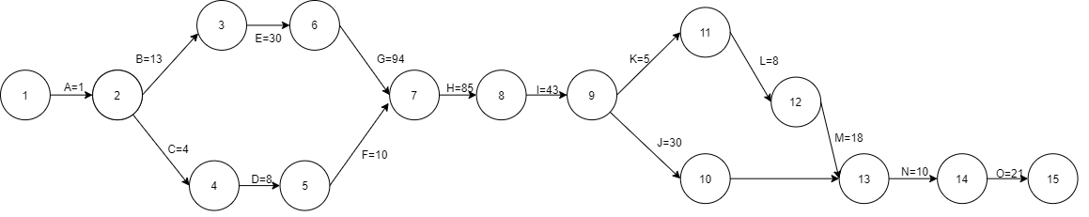

Network diagrams can display the logical relationships and the sequence of the activities and events of a project. It can be used to track each element of the project and share the project progress to our stakeholders and partners.

As the critical path is the longest path of the diagram, A-B-E-G-H-I-K-L-M-N-O is the critical path for our project which is 328 days in total.

**8.1) Herzberg theory**

The Two-Factors Theory by Frederick Herzberg can let organizations adjust the influence of motivation in the workplace.  There are two factors in this theory to analyse the current situation – hygiene factors and motivators.  For example, giving regular feedback to staff, increasing salary or providing health benefits and the like.  And we can apply this theory to Emily’s situation from these two aspects to retain her in the company.

**8.2) INDIVIDUAL IDEAS:**

**Chan Yik Kit (56237852):**

It is understood that Emily lost her interest as she was not developing her private equity skills in the project. In my opinion,  Emily can be involved in the project to contribute but the project is not much related to her strength. I suggest that rather than let her become an administrator of this project, let her be in the private equity position in the next project or the other related project to make it fairer to other members of the project, while Emily is suggested to attend the related training classes to develop her interest area in this time which the training fee paid by the company.

To motivate and satisfy her feelings about the work would be a solution. If she could not leave the position in the current project, I suggest the project manager or company can provide some bonus after finishing the current project to attract and enhance the team power and correct some personal behaviours of some individuals. When Emily contributed to the success of her team and the project, she will build the security sense and confidence of her work in more areas.

Anyhow, the project manager should make the right member register for the position in a project based on their skills, interest, and the project direction to reduce trouble or misunderstanding like Emily's situation. Also, a company should consider the strength and interest of each employee to make the highest contribution to the project which ensures to make the richest profit and the best performance, otherwise, it is the loss of the company if the talents are gone or lazy on work. Moreover, the company should provide more internal training to develop employees' talent and make better human resources management of the position registry of projects.

**Lai Justine (56235545):**

As the Project Manager, I will propose to provide a lump sum bonus once the current project has been completed to Emily and team members.  It will be an incentive for team members to decrease their dissatisfaction and put more effort into the project to make the project successful.  However, it is just an instant solution for the current situation.  We need to use other motivators to retain Emily in the company in the long run.

The main reason why she started coming into work late and the quality of work deteriorated was she had lost interest in the job.  She is a private equity expert, but the current job does not involve private equity.  She was just working as an administrator as other team members do.  She felt unmotivated because she thought she was undervalued.  She was not developing her private equity skills, and she worried about finding a job that involved private equity in the next project.  As the Project Manager, I can guarantee her next project will be in the private equity area.  Once she can focus on her expertise, she will have interest to keep working in the company.  Therefore, if Emily is guaranteed to be in the private equity position in the next project once she changes her working attitude in the current project, her concern will be solved, and she can focus on the project she was working on.  It also can increase her recognition in work.  She will feel valued in the company as she contributed to the success of her team and the project.  She may build a sense of security and increase her confidence in work.  This will motivate her to work great and feel satisfaction.

Also, as the Project Manager, I can encourage her to try different positions in a company in order to understand the work flows and the operations among different departments in the company.  She will have the whole picture about the project.  List out the advantages of being an administrator that can help her to enjoy the work she was working on.  Explain to her when she is involved in this project, she can develop the skills in communication and supervision.  This is an important soft skill for an administrator job.  It needs to interact with different people in different forms of communication.  Also, she can learn problem solving skills in administrative work.  If she is good at problem solving, she could handle conflict, teammates' relationships and troubleshooting easily.  She will gain teamwork and creative thinking skills too.  That will benefit the growth and advancement of her career path.  She should cherish this experience.

I will also persuade her that she has the responsibility to finish the current project in better quality.  Since the project has been working for 6 months, it was half-way to completion.  Her unresponsive attitude was obvious, showing that she was giving it up.  No matter how she did not like it, it was her decision to start this project.  Commitment is essential in the workplace.  Therefore, she should take up the responsibility to complete the project and communicate well with her team members.

**Tsang Yung (56273550):**

In Emily's situation, she lost interest after the project direction had been chosen, because the project is not related much to her own profession. She felt kind of aimless that she can't develop her own skills as a private equity expert. Therefore, she started late for work because she felt it was a waste of time, her work quality dropped a lot because she got distracted and lost motivation to work, and not communicate with other members because she thought the problems, she was thinking of would bring trouble to the others.

As the project manager, I found out that she wants to develop and apply her own skills in a project. So, I have decided several ways to solve the issue.

Since the project already begins for 6 months, it is not reasonable and not fair if I transfer her into another project which suits her own preferences. I would persuade her to stay and promise her a better treatment in the next project which fulfils her needs of using her private equity skills. Also, I would guarantee her some training which is related to her expertise in order to develop her own skills. The training fee would be paid by the company. Once her conscientiousness on her skills development is solved, she would be able to focus on the project she is currently working on and be productive again. And she would be able to communicate with other members again and build up a sense of belonging to the team which can also bring her more motivation to work.

On the other hand, a bonus will be set in the project in order to motivate all of the team members to do their best in it. And I would make sure to put the members in the right place to prevent the situation like Emily from happening again. Otherwise, it would be a great loss if every member lost interest or got distracted by any possible problems which are possible to avoid.

**9) RACI Chart**

**Group Members Duty**

R: responsibilities A: accountability (only 1 A per task) C: consultation I: informed

|  |  |  |  |
| --- | --- | --- | --- |
| **Project Activity** | **Amy** | **Justine** | **Rosita** |
| 1.1 Business case | R, A | C | A, I |
| 1.2 Project Budget Plan | R, A | I | C |
| 1.3 Business Model Canvas | R | I | C, A |
| 2 Stakeholders Register | R | C, I | A, I |
| 3 Weighted Score Model | R, A | C, I | I |
| 4 Project Charter | C, I | I | R, A |
| 5.1 Work Breakdown structure (WBS) | I | C | R |
| 5.2 User Requirement Traceability Matrix (RTM) | C | I | R |
| 6 Gantt Chart | C, I | R | C, A |
| 7 Network Diagram | C | R | A, I |
| 8 Herzberg Theory | C, I | R | A |
| 9 Cost Analysis of outsource | R, I | A | C, I |
| 10 Contact Strategy | C, I | R, A | C, I |
| 11 Risk Management | R, A | C | I |

The above table shows the RACI duties of each group member.

Amy is the project manager and mainly contributes to the business management parts of accounting, budgeting, stakeholder registering, score weighting, and risk management because she is sensible in business-related management and she is the one who provided the idea of the project – the IoT system of the vending machine. Therefore, she is responsible for such parts and mainly be consulted at the other parts.

At the same time, Justine as an administrator and assistant is responsible for the duration and progress management of the project as she had the sense of time management and scheduling skills to ensure the project running, also she is good at showing a detailed progress path by charts and tables. She needs to be consulted in the business management part as she has to control the time element of the project which affects the project very much.

Last but not least, Rosita is responsible for projecting the charter of the project and user requirement controls to ensure the work breakdown structure of the project and consulted at the business part as well. The position of Rosita is an administrator and assistant of accounting and other parts. Therefore, she needs to do more accountability in the position of parts to ensure the quality and accuracy of each part.

**RACI CHART - Project Stakeholder**

|  |  |  |  |  |  |  |
| --- | --- | --- | --- | --- | --- | --- |
| **Project Activity** | **Project Manager** | **Programmer** | **UX/UI Designer** | **Consultant** | **Finance** | **Sales** |
| **1 Business Case** | R, C | I | I | C, I | A, C, I | I |
| **2 Stakeholders** | R, A | I | I | C, I | I | I |
| **3 Weighted Score Model** | R, A | I | I | C, I | C, I | I |
| **4 Project Charter** | R, A | I | I | R, C, I | I | I |
| **5 Work Breakdown structure (WBS)** | R, A | I | I | I | I | I |
| **6 Gantt Chart** | R, A | R, I | R, I | C, I | I | R, I |
| **7 Network Diagram** | R, A, C | R, I | R, I | I | C, I | I |
| **8 Herzberg Theory** | R, A, C | I | R, I | C, I | C, I | I |
| **9 Cost Analysis of outsource** | R, C | I | I | C, I | R, A, C | I |
| **10 Contact Strategy** | R, C | C, I | C, I | A, C, I | R, C | I |
| **11 Risk Management** | R | I | I | C, I | A, C, I | I |

The above RACI chart shows the RACI duties of each registered project stakeholder. A project manager is a most important character of a project who is responsible for all parts in the stage of project management. At the same time, consultants mainly work on consultation duties while programmer, user interface (UI) designer, user experience (UX) designer, sales mostly to be informed and just responsible for position related duties. For finance, they are responsible for the business part and accounting-related parts then consulted and to be informed in other parts.

**10.1) Cost Analysis of outsource (including cloud services) vs in-source**

|  |  |
| --- | --- |
| **Cost Breakdown of Alternatives** | |
| **Alternative 1: Outsourcing** | **Alternative 2: In-sourcing** |
| Direct Costs | |
| **Contract cost**   * Total contract cost * Duration of contract | **Personnel**   * Salaries * Benefits * Time of work |
| N/A | **Supplies**   * Unit price * Amount Consumed |
| N/A | **Equipment**   * Unit price or commercial equivalent prices * Depreciation |
| Indirect Costs | |
| **Training**   * Cost of personnel facilitating code of conduct ​training | **Training**   * Cost of personal participating in all training * Cost of personnel facilitating all training |

|  |  |
| --- | --- |
| **Benefit Breakdown of Alternatives** | |
| **Alternative 1: Outsourcing** | **Alternative 2: In-sourcing** |
| Cost   * Reduce labour costs * No need to hire more employees | Cost   * Use the company's existing resources * Save communication costs |
| Professional   * Unlimited existing professional knowledge and skills * business operations more flexible | Security   * Sensitive and confidential information will not be threatened. |
| Efficiency   * Increased profits * reduced costs * capital can be more efficient |  |

**10.2) Contract Strategy**

A contract is an agreement made between the owner and employees that are protected by the law to provide something in return.  It can guarantee the profit of different parties.  First, for the termination of the agreement, it can let both sides have more time to hand over the work in given days.  If the owner or employees didn't complete all the obligations according to the agreement, they need to pay for the liquidated damages and penalty.

Second, a good filing system for the contracts.  Developing robust document storage and showing facilities is important.  There are many sensitive documents and information for each project, having a good filing system can ensure the privacy of internal documents and ease to management.

Third, transparency. It is essential to build in obligations to give you the right of visibility and accuracy on all the information you need in order to manage the contract effectively.

Lastly, proprietary information.  As an employee with the company will involve access to and creation of confidential and secret information.  Employees must keep all proprietary information in trust for the sole benefit of the company. Employees should not use or disclose any private information even after the termination of the contract.

And there are different advantages for outsourcing and insourcing.  Outsourcing employs an external organization's skilled labour to complete tasks, as well as its resources for providing services and manufacturing goods. Outsourcing work to another company is usually motivated by a desire to save money on expenditures.  Instead of employing an outside individual or organization, insourcing assigns a project to a person or department within the company. It makes use of the organization's developed resources to complete tasks or achieve a goal.

For outsourcing, as it is a short-term contract, the price for outsourcing will be listed in the contract. It can manage the project cost easily.  Also, it is relatively cost-effective for outsourcing. Outsourcing allows businesses to save money by completing the same tasks for a lower cost. Even when the task is completed for less money, the quality does not suffer as a result of the service providers' specialized skills. The best outsourcing benefit is certainly lower costs while maintaining or even improving service quality.  And outsourcing companies usually specialize in a specific task.  Outsourcing company will give company a competitive advantage over competitors if you outsource some functions.  Companies will have more resources and time to enhance their skills and remain competitive.  Therefore, you can hire expertise more cost-effective as it is a short-term engagement.

For insourcing, it will give businesses more control over decision making and the capacity to move faster when the project is seen as critical to the company’s success.  In addition, insourcing usually involves bringing new activities and processes throughout. As a result, insourcing might be more costly for a firm because it frequently necessitates the administration of new processes in order to launch a new division.  Also, the company will be able to build talent if you consistently outsource assignments for years.  Company would have employed employees and worked with them for a long time. During this time, the company had access to the entire skilled workforce of its team.

**11.1) Risk Management**

**Project Risk Register**

The severity rating is based on the impact and likelihood. In the register, the person who will manage the risk is referred to as the owner. Actions to mitigate the risk, such as reducing the likelihood and actions to be taken if the risk occurs, are known as mitigating action and contingent action. In the following is the Severity Table for reference to the 5 key risks register.

**Table 11.1 Severity Table of the 5 Key Risks Register**

|  |  |  |  |  |
| --- | --- | --- | --- | --- |
|  |  | Likelihood | | |
|  |  | 1 | 2 | 3 |
| Impact | 1 | Low | Low | Medium |
| 2 | Low | Medium | High |
| 3 | Medium | High | High |

**Table 11.2 5 Key Risks Register**

|  |  |  |  |  |  |  |  |
| --- | --- | --- | --- | --- | --- | --- | --- |
| **5 Key Risks Register** | | | | | | | |
| **ID** | **Risk description** | **Likelihood** | **Impact** | **Severity** | **Owner** | **Mitigating action & Contingent action** | **Progress on actions** |
| 1 | The project purpose and need are not well defined. | M | H | H | Sponsor | If no business case has been provided, create one and ensure the purpose is accurately outlined in the Project Charter and Project Identification Document (PID); Report to the Project Board and assess the risk of runaway costs or never-ending projects. | Rewritten the business case to include clear deliverables and sent to the project board. |
| 2 | There are no clear or understandable definitions or descriptions of the project schedule | L | M | M | PM | Conduct weekly meetings with the project team to share the plan and review upcoming tasks. Hold planning workshops with them so they understand the plan and likelihood of missing tasks is reduced. | Scheduling the meetings. |
| 3 | Uncertainty and confusion caused by a lack of communication. | M | M | M | PM | Ensure that keep records of meetings and communications, including dates, aims, and stakeholders, and use the most appropriate communications channel to ensure that are contacted and any misunderstandings are corrected immediately. | Keep make records on any communications. |
| 4 | It is possible to increase error risk by unilaterally shortening tasks or running them in parallel. | L | H | M | PM | Sharing the schedule and explaining the risks of the changes with key stakeholders can help reduce the possibility of this happening; Communicate with decision makers and source of pressure to assess the risks and impacts. | The timetable is still being finalized. |
| 5 | Acts of God for example, extreme weather, leads to loss of resources, materials, premises etc. | L | H | H | PM | Familiarize the project team with emergency measures and make sure the insurance is in place. Follow all health and safety requirements and alert the project team and stakeholders. | Public Liability Insurance confirmed along with any additional premises insurance. |

**Table 11.3 Probability/Impact Matrix**

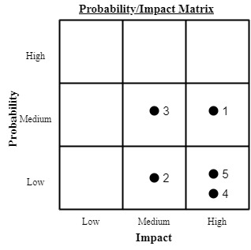

Here is the probability and impact matrix reference for the above key risk register. Mostly it is distributed in the range of low to medium probability and medium to high impact, especially (4) and (5) have high impact.

**Table 11.4 Decision Trees and Expected Monetary Value (EMV)**

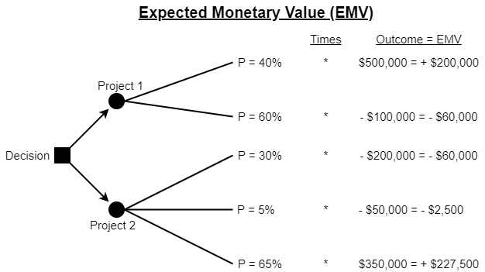

The main difference between the above project 1 and 2 is the start location of the project, project 1 is going to hold the project in mainland China and project 2 is Hong Kong. As the following of the result is:

Project 1’s Expected Monetary Value = $200,000 - $60,000 = $140,000

Project 2’s Expected Monetary Value = - $60,000 - $2,500 + $227,500 = $165,000

Without risk probability, we will select project 1 as it is expected to make $500K if compared to Project 2 with $350K. But if you include the risk probability evaluation, then project 2 is better.

**END**

**Appendix A: Coursework Assessment Form**

|  |  |
| --- | --- |
| **Student Number** | **Student Name** |
| 56237852 | Chan Yik Kit |
| 56235545 | Lai Justine |
| 56273550 | Tsang Yung |

Date & Time of presentation: 15-Nov-21 (Mon) 12:00 to 12:30 - Team 2